Winter Festival
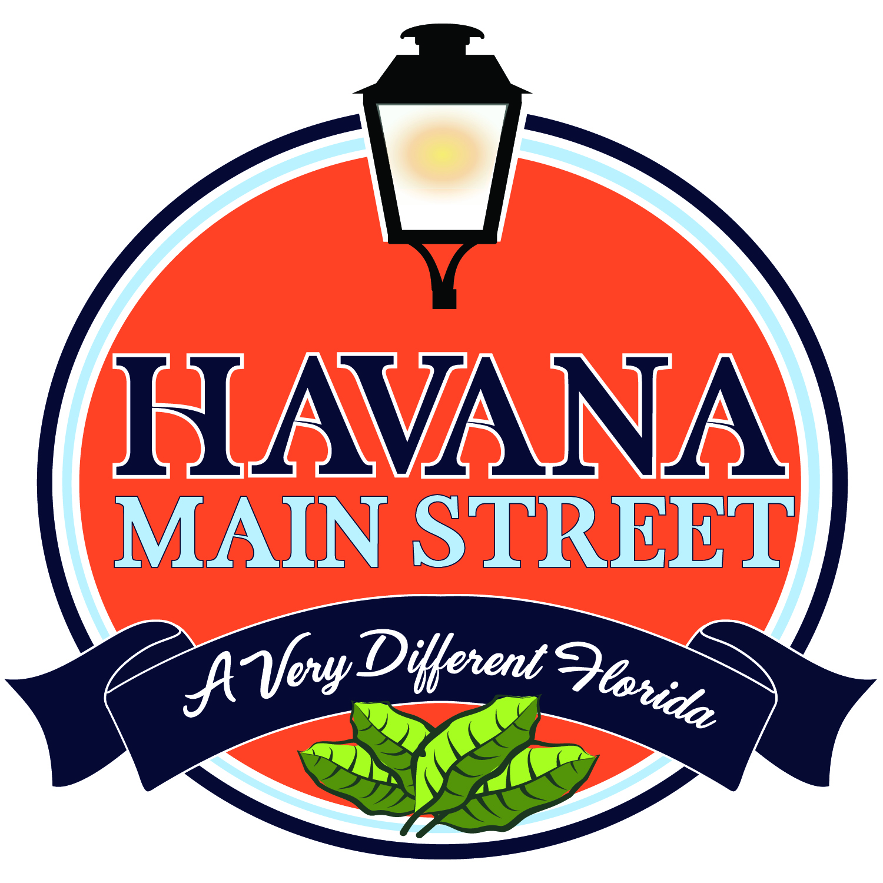
December 10, 2022
Vendor Application
The event Chair and/or Booth Coordinator have absolute right of refusal of any booth vendor. If vendors apply and are refused, their application fee will be returned. NOTE: (Make checks payable to Havana Main Street)
Business / Vendor Name:__________________________________________________________________________
Name: Phone
Address:
Email:
Description of merchandise/food to be sold or activity to be carried out :

State Sales Tax #: State License # (if applicable):_________________
Circle Your Business/Vendor Category -- Electrical is $25 additional for all vendors Electrical ________

- Standard Vendors Booth Space 10 x 10 $75.00

- Non-profit, Informational Booth Space 10 x 10 $35.00
- Non-profit, Selling Booth Space 10 x 10 $50.00

- Food Vendor (Prepackaged) Booth Space 10 x 10 $75.00
- Food Vendor / Onsite Consumption Small Booth Space 10 x 10 $150.00
Large Booth Space 10 x 20 $250.00
You will prepare and sell food onsite that will be consumed onsite.

Rules (All Vendors): Vendor is responsible for providing all necessary equipment, tables, extension cords, rain covering, etc. Event officials reserve the right to refuse the display/sale of any item that is offensive, obscene, or otherwise not in keeping with the family atmosphere of the festival. Political merchandise sales or information is not allowed. Vendors will accept the location assigned and remove vehicles from site at designated times. Please do not block merchant entrances. You will be responsible for site cleanup at the time of the event closure. NO PETS ALLOWED. ALL VENDORS ARE TO REMAIN IN PLACE UNTIL 5:00 P.M. or other announced time.
Food vendors only: Tents must be made of fire retardant materials if food is cooked on site. Vendor must recapture any wastewater, cooking materials and ALL trash. No generators will be allowed unless permission has been given.
REGISTRATION AND PAYMENT MUST BE RECEIVED BY NOVEMBER 30TH. NO REFUNDS will be given for any reason. Spaces must not be shared or sub-let unless prior approval is received by event staff in writing. Set-up time will be 7:30 A.M.- 9:30 A.M., and vendors should be open for business by 10:00am. NO LATE SET-UPS WILL BE ALLOWED.
I agree to comply with all state and local requirements as well as the rules stated within this application. I understand that I am required to secure any licenses/permits, etc. required by all governing authorities that may have jurisdiction over products to be sold as described above. I will remain open during the times set for the event. I hereby release and forever discharge from liability the Town of Havana, the Havana Main Street, and/or the event, its sponsors and their affiliated companies, businesses, officers, agents and employees. I will NOT hold event or event organizers responsible for loss due to theft, damage or acts of God. I understand that this event in no way guarantees any returns or benefits.

Signature Date

RETURN APPLICATION AND CHECK TO: Havana Main Street, PO Box 346, Havana, FL 32333

FOR QUESTIONS: Contact Nancy Saunders, Festival Coordinator, at (850) 567-4281, blackcrowllc@yahoo.com or havanamainstreet@gmail.com

